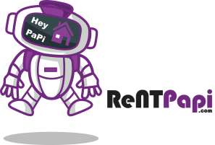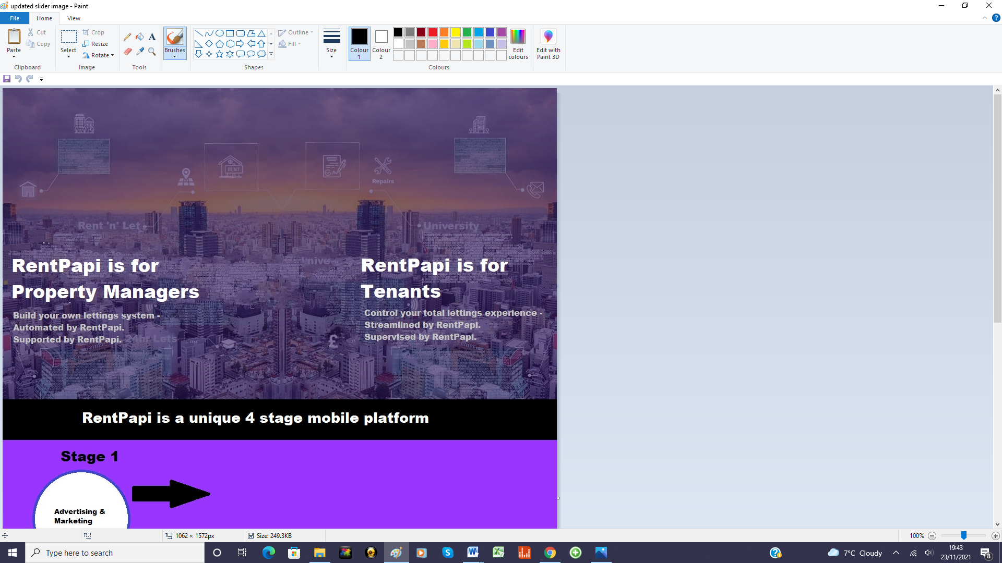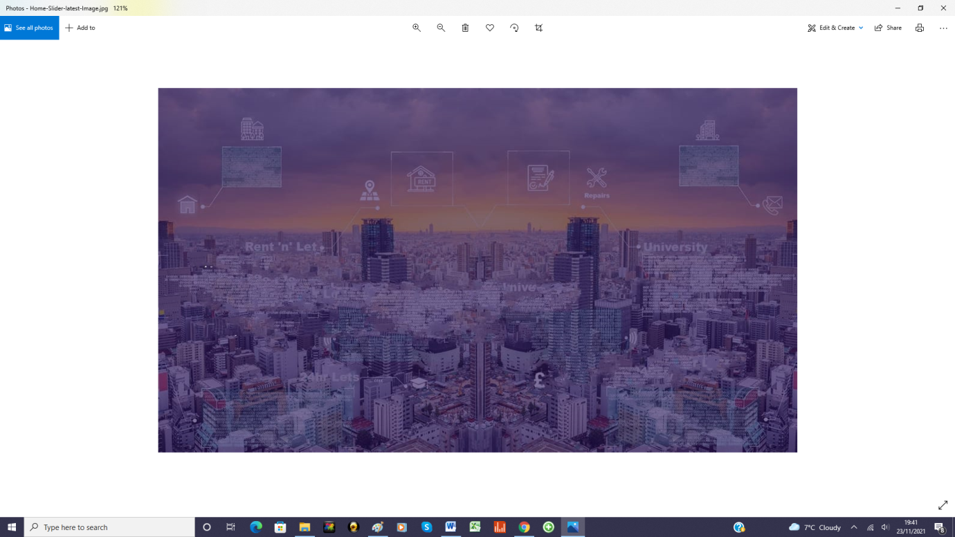

**RentPapi is a unique 4 stage mobile platform operating on the ‘cloud’ that guides, supports and automates many lettings processes and services into one efficient and effective  
 Rent ‘PaPi’.**

**It is built on 3 simple aims:**

1. **To empower property managers to customise a lettings system that seamlessly works for them.**
2. **To ensure every tenant user receives an individualised yet effective experience .**
3. **To deliver a totally frictionless journey throughout the tenancy lifecycle.**

Stage 4

Stage 3

Stage 2

Property Management

Tenancy Management

Tenancy Creation

Stage 1

Advertising & Marketing

